**Data Visualizations:**

1. Does offensive defensive players tend to be taller on average?

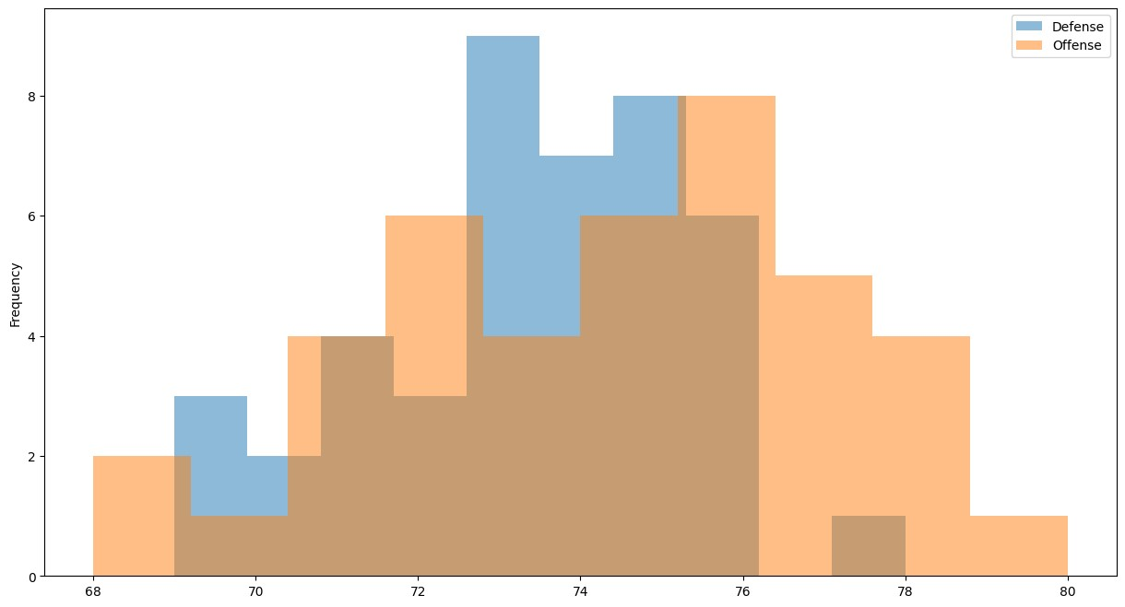

1. Show the proportion of class by each position on the ND football team.

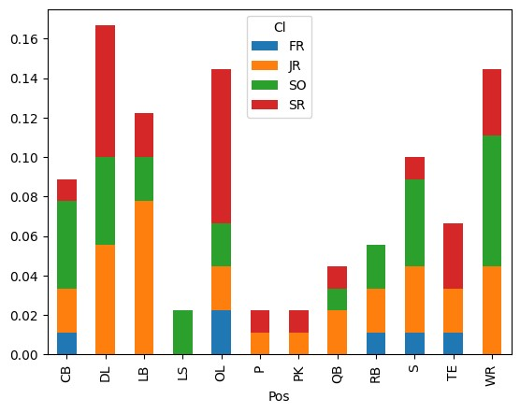

1. Display the breakdown of class by Defense, Offense and Special Teams.

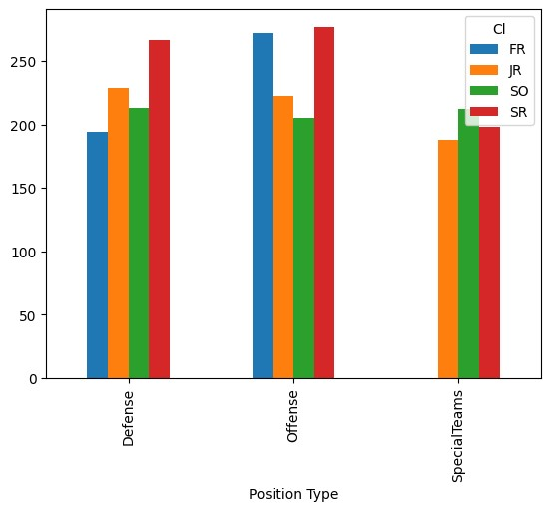

]

1. Show the percentage of male female survivors of a particular plane crash.

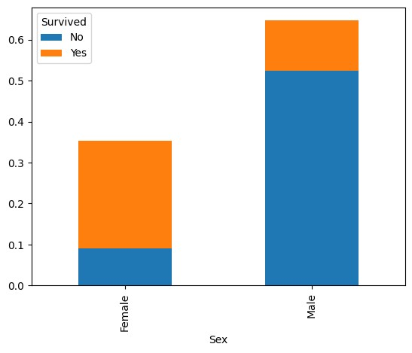

1. Show the relationship between horsepower and the MPG on the highway.

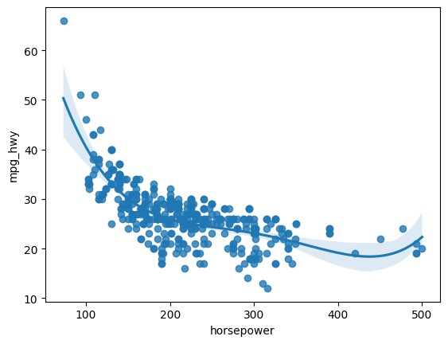

1. What is the relationship between the number of cylinders in a car and the MPG on the highway?

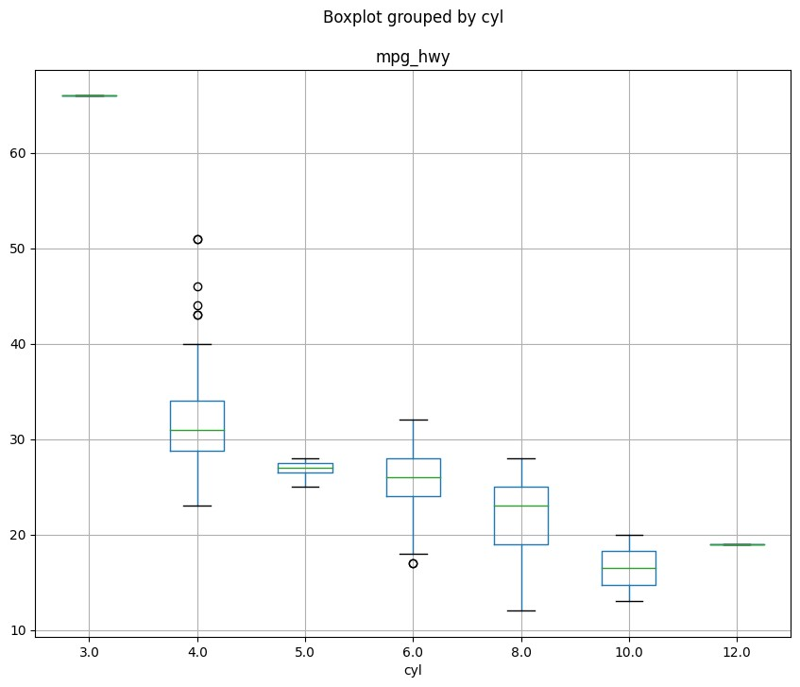

1. Show beer production over time.

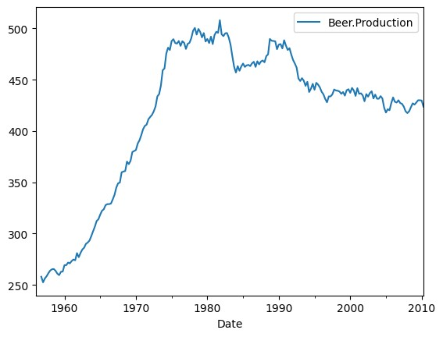

1. Do different sports fans have a preference for particular types of food at games?

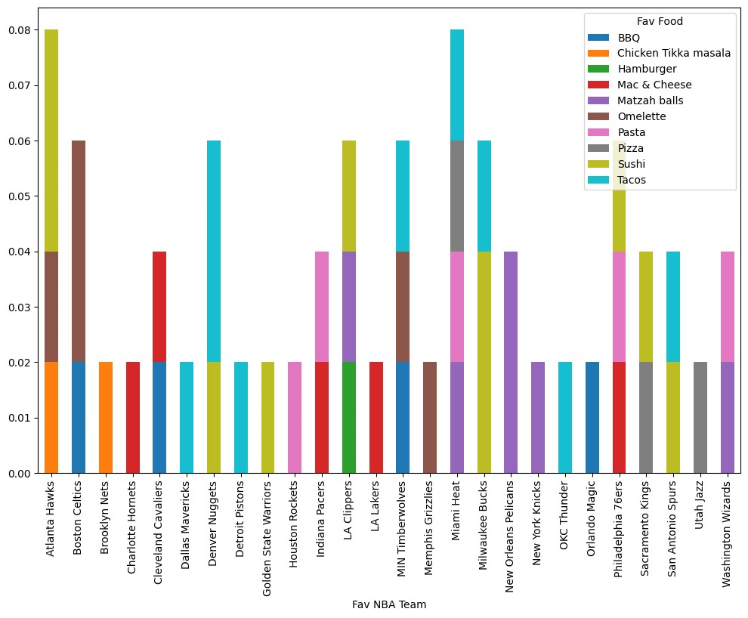

1. Display number of crimes by state in ascending order.

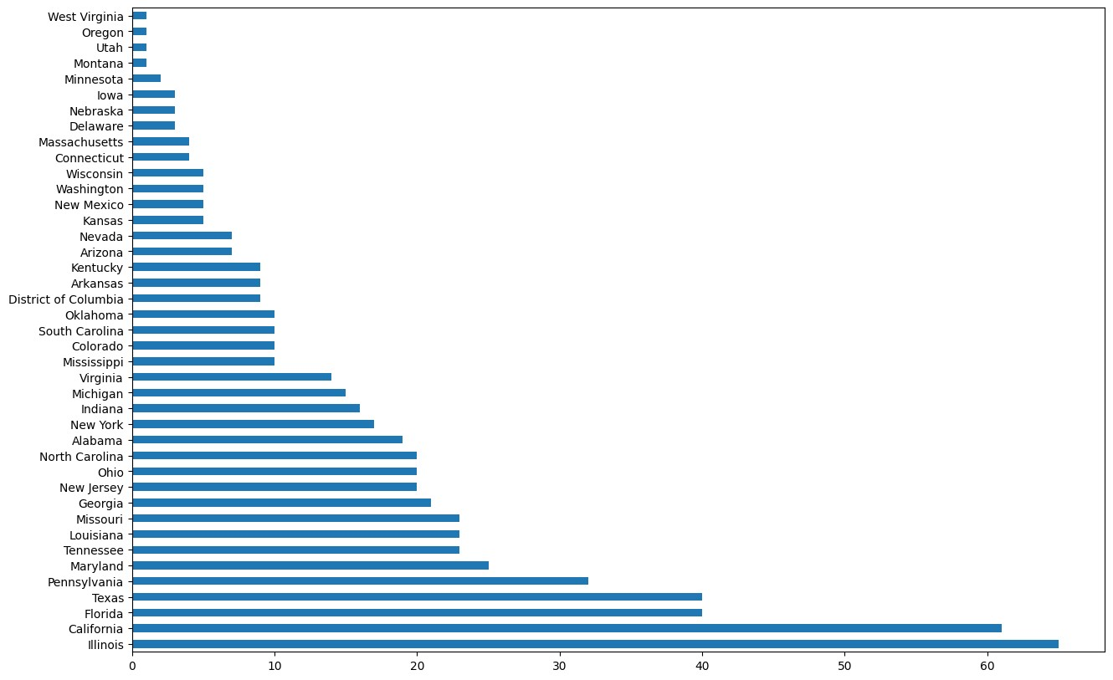

1. Make a word map for shooting cases to visualize words most often used.

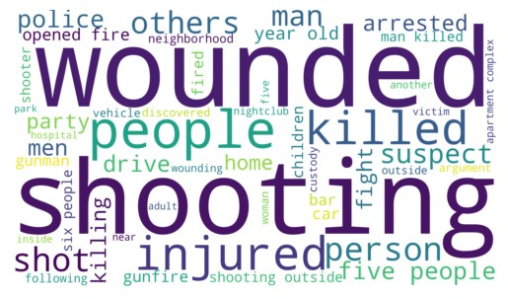

1. Compare the relationship between hand size and height.

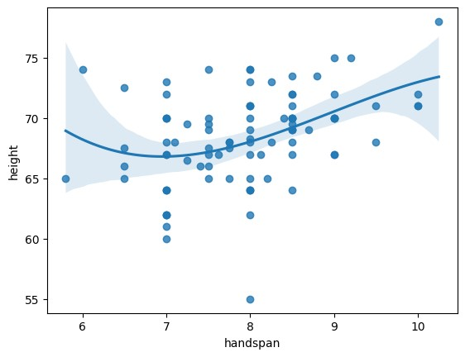

1. Compare the relationship between shoe size and height in both males and females.

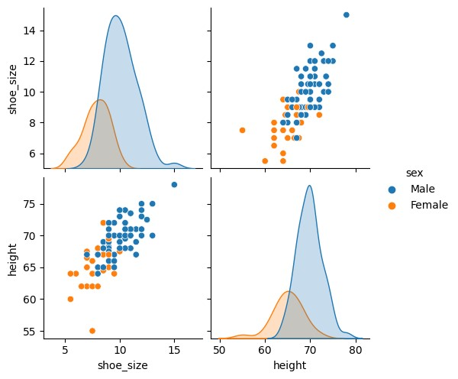

1. Compare the average height of males vs females.

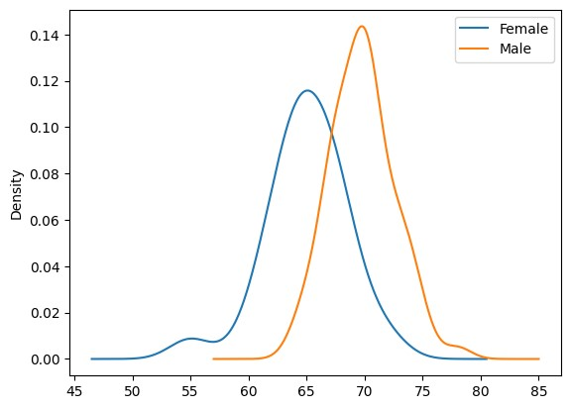

1. Are female/male athletes taller on average than non-athletes?

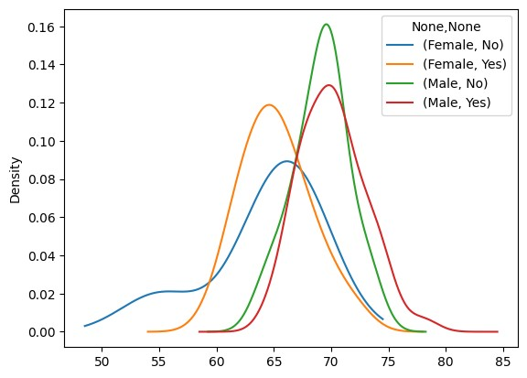

1. Are Shark Tank investors biased to particular industries?

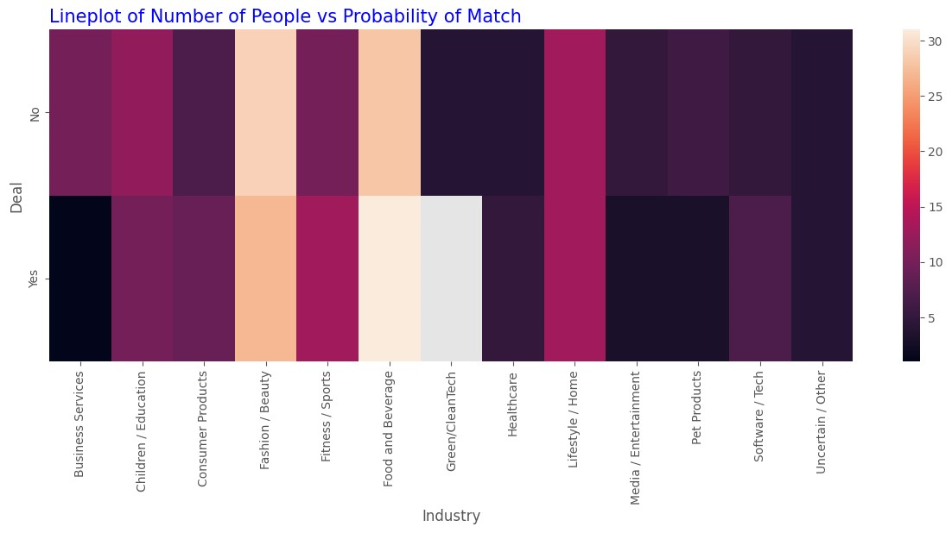

Does the amount invested in a company a good predictor of that company’s success?

1. Is the amount invested in a company a significant predictor of success for that business?

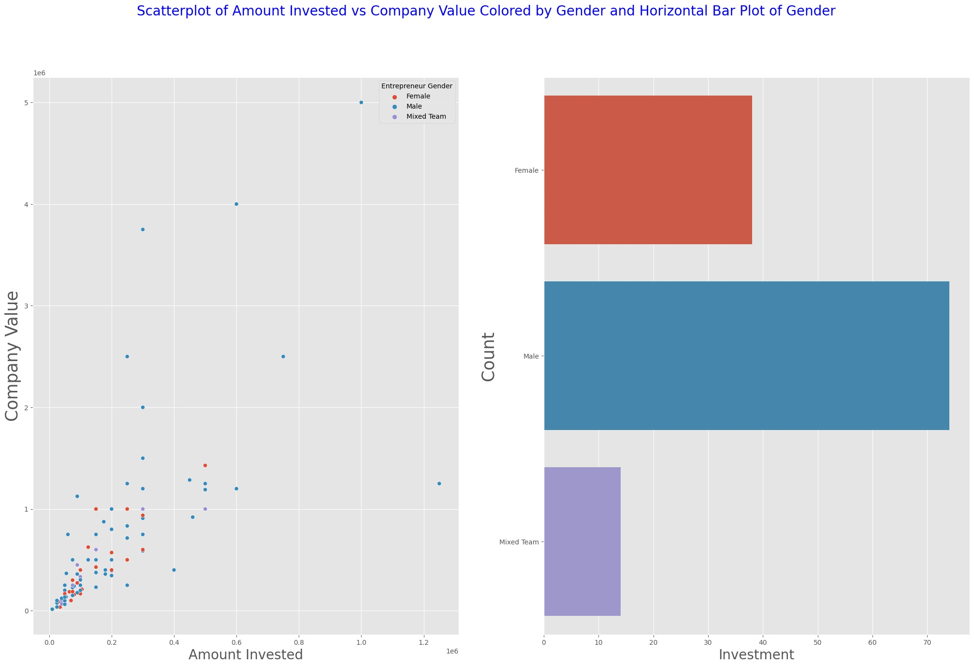

1. In speed dating, what is the probability of a match given the amount of people in the room?

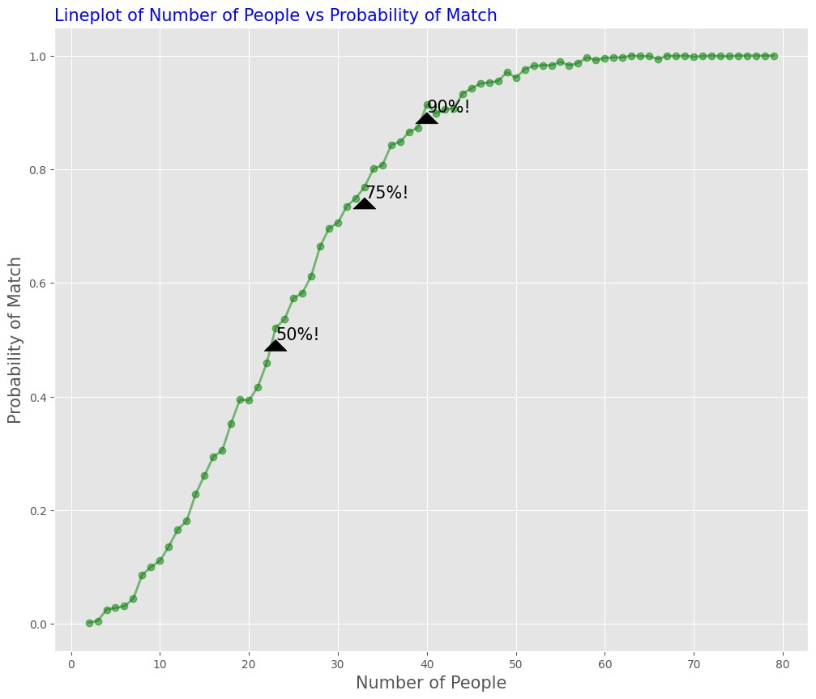

1. Compare the average delays between the top five destinations among the top 3 busiest airports.

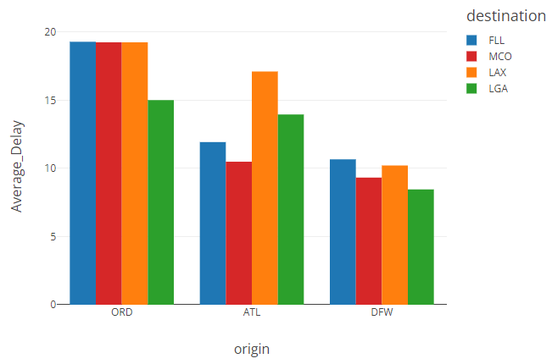

1. What is the relationship between the top 3 busiest airports and the average delays by day of the week?

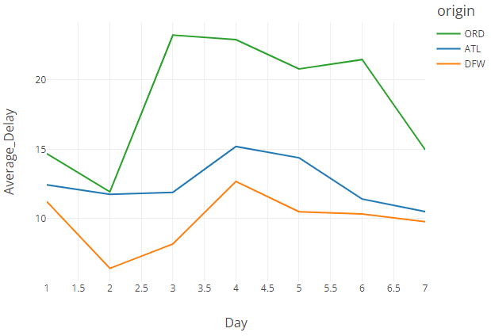

1. What is the relationship between the number of bedrooms and the total value of the house?

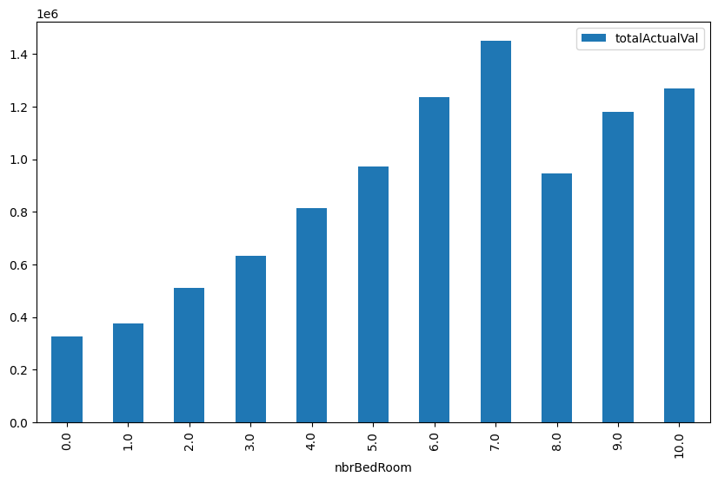

‘

1. What is the relationship between the year built and number of rooms in the overall value of the house?

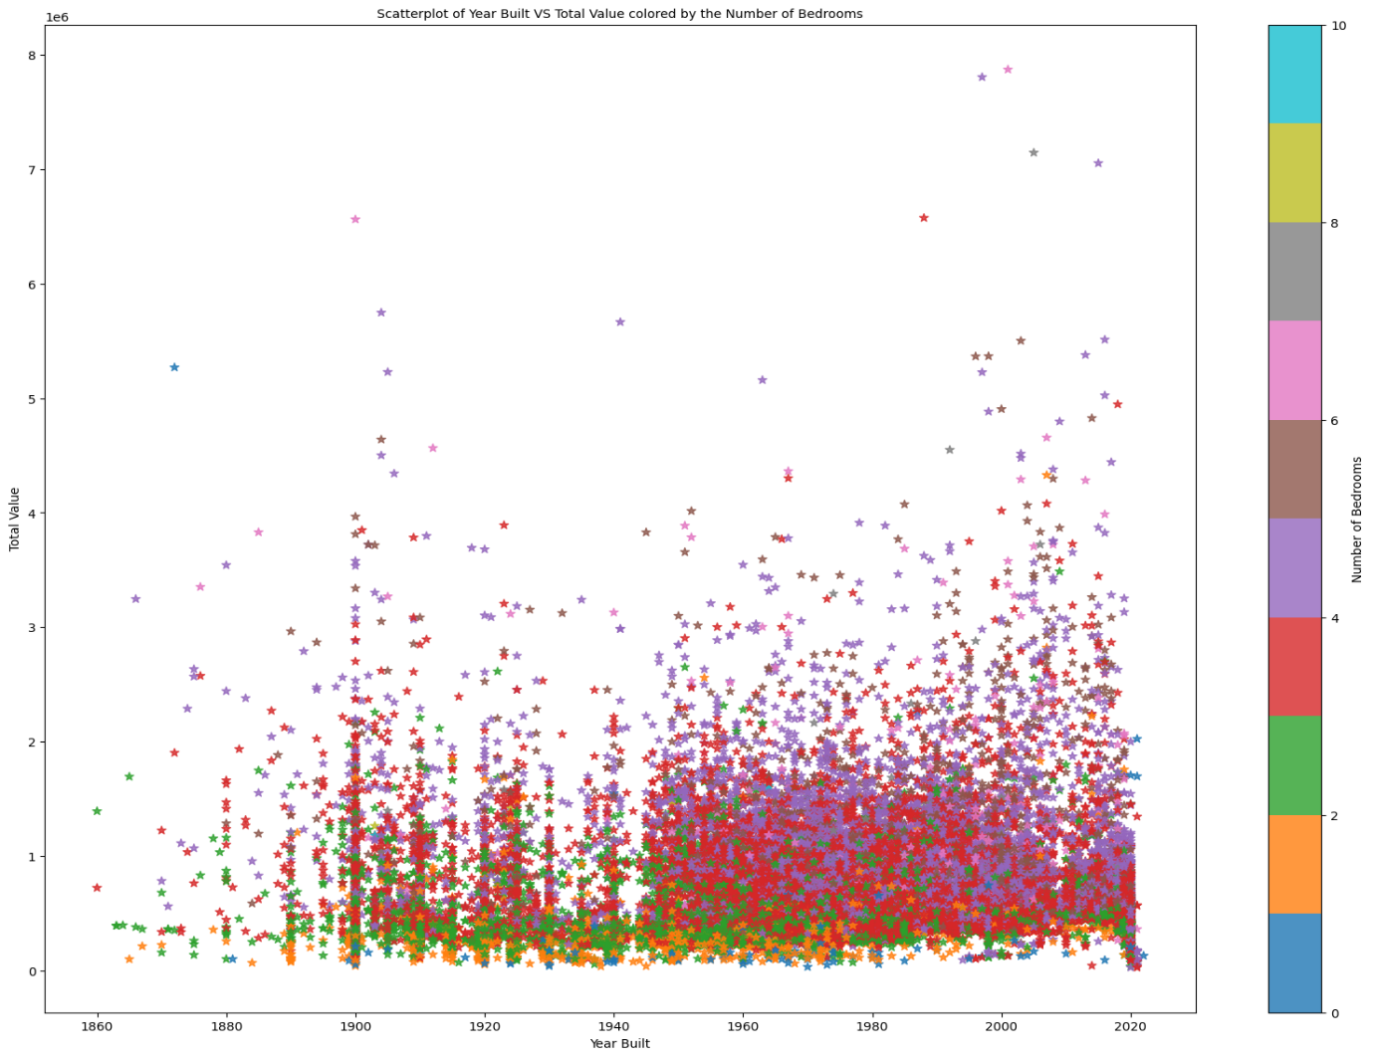

1. Who pays the bill more often: men or women?

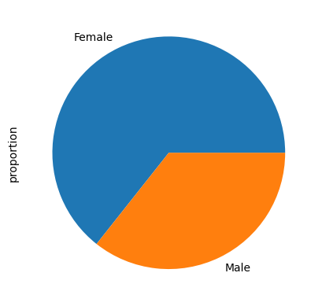

1. Which day of the week is best for tips?

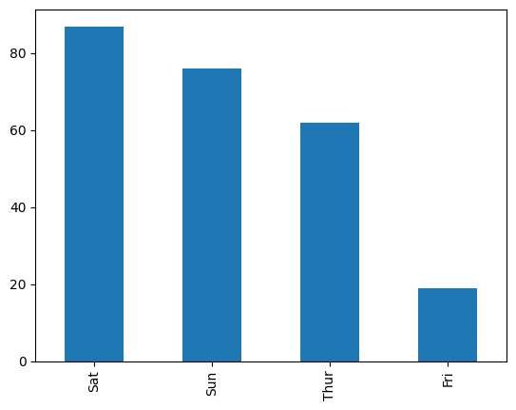

1. What amount of cotton is necessary to maximize tensile strength in the fiber of clothing?

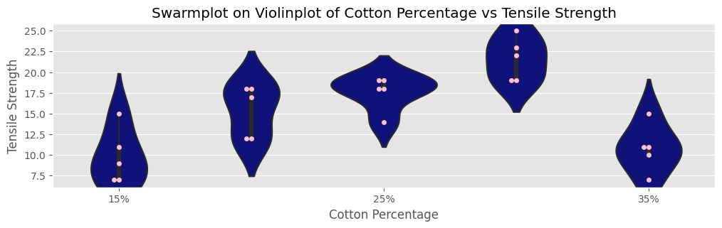

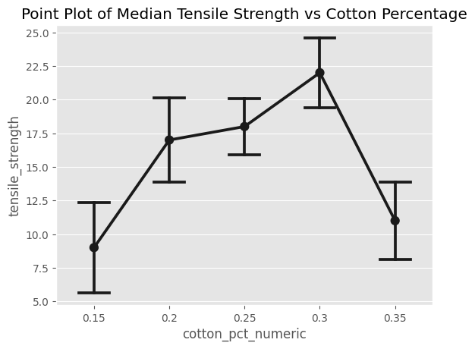

1. Is there a relationship between leaf size and nicotine content?

